NeuroMEP – Questions for the Engineering Team
Prepared 2 November 2026 for the MD and the Senior Electrical Engineer · WBS 1.5.5 engineering handover (due 4 November 2026)
NeuroMEP sizes every breaker and cable automatically. The software is built and tested, but some engineering values must come from you. Until they do, every result is marked Provisional and cannot be issued as Final.
We have studied the files you shared (the component spec, the CableSizer v1.1 workbook, the DB schedules, the manual and both presentations). Some questions are now answered; the ones below are still open. For each question we show what we have now, why it matters and what we need from you. A short answer per question is enough.

Part A – Needed before the calculation engine is built (5–6 Nov)

Q1. Which cable current-rating tables should we use?
What we have: the Ducab tables inside CableSizer v1.1 (based on BS 7671:2001).
Why it matters: these tables decide the size of every cable. They are over 20 years old and have never been checked against current Ducab catalogues or BS 7671 tables. A wrong value gives an undersized cable (overheating, fire risk) or an oversized one (wasted cost).
What we need: the current Ducab catalogue (or the BS 7671 tables you want used) for each cable type we offer: PVC / XLPE / fire-rated, Cu / Al, armoured / unarmoured, 1–4 core. Please also tell us which table each dropdown choice should use.

We will base it on the Ducab catalogue; We do not have the latest edition of BS & IEC standards. Will try to get those standards.

Q2. What demand factors should be the defaults?
What we have: example values from the Dubai Promenade project. They change with the board level:

Board | Lighting | Sockets | HVAC | Water heater | Laundry | Kitchen | Spare
DB | 1.0 | 0.8 | 1.0 | 0.8 | 1.0 | 0.7 | 1.0
SMDB | – | 0.6 | 1.0 | 0.4 | 0.4 | 0.6 | 0.8
MDB | – | – | – | – | – | – | 0.8
Why it matters: demand factors decide the maximum demand, which decides every breaker and cable size upstream and the transformer size. Today NeuroMEP uses 1.0 (no reduction), which is safe but oversizes everything.
What we need: (a) May we use the table above as company defaults? (b) Do factors depend on the building type (residential, office, retail, landlord), and how should they combine when one panel serves several types?
(c) Should each board apply its factor to the connected load (as CableSizer does)?

As mentioned in the briefing document we need to have the option of calculating demand loads based on load categorization (landlord, residential, office, retails as one option; second option would be to provide the user to plugin the demand factors for each group of loads namely lighting, sockets, hvac, etc.

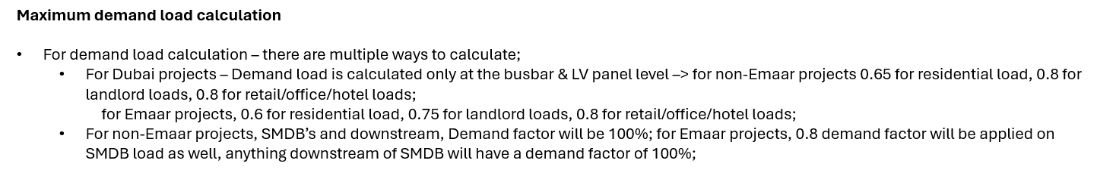

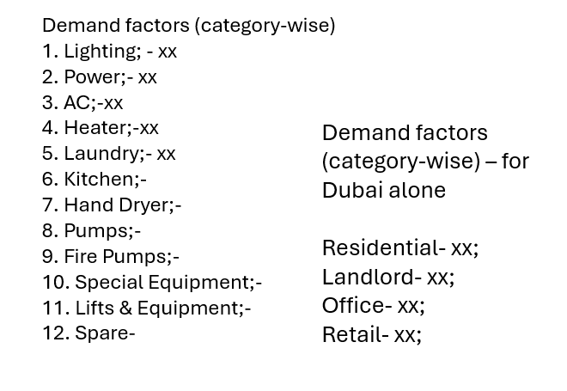

The above option with manual inputs should be available on the project setup sheet;

Q3. Which breaker catalogue should we use?
What we have: standard ratings, fault ratings per type (MCB 6–25 kA, MCCB 25–65 kA, ACB 50–85 kA) and a Merlin Gerin magnetic-trip / disconnection-time table.
Why it matters: without the manufacturer's data (Icu, Ics, Icm, let-through energy I²t, tripping curves, derating at 50 °C) we cannot prove that a breaker clears a fault in time or that the cable survives the fault. Those checks show "Device data required" today.
What we need: the breaker catalogue you use (brand and range), and the limit up to which MCBs are used (we assume 63 A for now).

I don’t think this is required;

Q4. Which site conditions apply in Dubai?
What we have: CableSizer uses air 50 °C and ground 35 °C. The DEWA 2017 regulations state air 48 °C and ground 40 °C, soil 2.0 K·m/W.
Why it matters: a hotter ground means buried cables carry less current. Using 35 °C instead of 40 °C can give buried cables that are too small.
What we need: confirm the values to use: 50 / 35 °C (CableSizer) or 48 / 40 °C (DEWA 2017).

48/40 is the correct value however the catalogues may not have derating factor corresponding to 48deg.C so we can use 50deg for air and 40deg for soil;

Q5. Which editions of the standards apply?
What we have: CableSizer follows BS 7671:2001 (16th edition), IEC 781 and IEC 364, which are all superseded.
Why it matters: formulas, limits and tables changed between editions. Authorities and clients check designs against the current editions.
What we need: the editions to apply (for example BS 7671:2018+A2, IEC 60909, DEWA regulations year).

We do not have the current edition of these standards. We can base all the cable details on Ducab catalogue.

Q6. Do you approve these corrections to the CableSizer method?
What we have: an independent check of CableSizer found some simplifications. NeuroMEP corrects them:

Item | CableSizer | NeuroMEP | Why
Fault voltage factor | c = 1.0 | 1.10 for maximum, 0.95 for minimum fault | c = 1.0 underestimates the maximum fault current
Voltage drop | fixed mV/A/m | resistance and reactance with the load power factor | more accurate for large cables
Earth-fault loop reactance | average of two sizes | phase plus protective conductor reactance | the average is not physically correct
Breakers inside panels | not derated | derated at 50 °C (manufacturer data) | panels are hotter than the room
Motor current | simple formula | includes motor efficiency | motors draw more than output kW suggests
Generator size | MD / 0.8 | MD / 0.8 plus largest motor start, confirmed by manufacturer | motor starting can stall a generator;  for this one, we just need to list down all the loads board-wise and provide the field for demand factors for both cases – power failure and fire mode;
Values between table steps | nearest value – rounded up/down whichever is more conservative; | straight-line in between; blocked outside the table | avoids jumps and guessing
What we need: "approved", or the items you want changed.

The green shaded ones are the ones to be adopted;

Q7. When does an ELCB / RCD replace the earth-fault loop check?
What we have: the ELCB choices (30 mA / 100 mA ELCB, 0–300 / 0–500 mA ELS) and the rule "shown in the remarks column".
Why it matters: with an ELCB upstream, a circuit may be safe even when the loop impedance is high. Without the rule we either fail safe circuits or pass unsafe ones.
What we need: when the earth-fault loop check may be skipped because of an ELCB, and which ELCB ratings apply.

When there is an elcb or rcd immediately upstream of the feeder, not at the feeder feeding the board, the earth fault loop check can be avoided.

Part B – Needed for scenarios and reports (6–9 Nov)

Q8. Which loads go on the generator, and what is the Generator Load Analysis?
What we have: load categories (normal, essential, critical, fire & life safety). Nothing on what the Generator Load Analysis report should show.
Why it matters: this decides the generator size and the power-failure and fire-mode checks. It is also the one report you asked to be editable.
What we need: which loads are supplied in power failure and in fire mode, and the layout of the Generator Load Analysis (columns, totals, what can be edited).

The loads categorized as essential, critical and fire life safety should be listed under generator analysis similar to the example included in the briefing ppt;

Q9. Transformer, generator and busbar data
What we have: IEC typical values (for example transformer %Z 6 %, generator X″d 14 %).
Why it matters: fault levels, breaker ratings and busbar checks depend on the actual equipment. Busbars show "Datasheet required" today.
What we need: standard transformer and generator sizes with %Z / X″d, and a busbar datasheet (ratings, resistance, reactance, short-time withstand Icw / Ipk, aluminium and sizes below 800 A).

Transformers

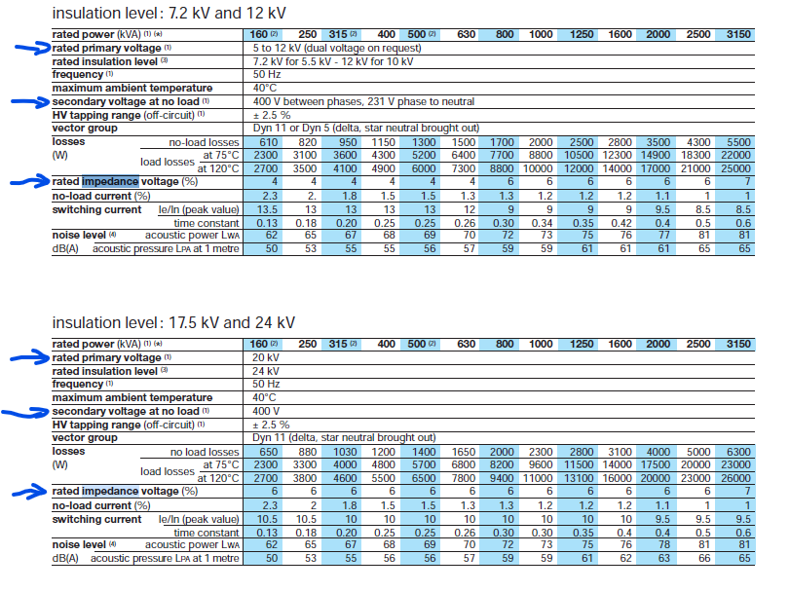

Generators

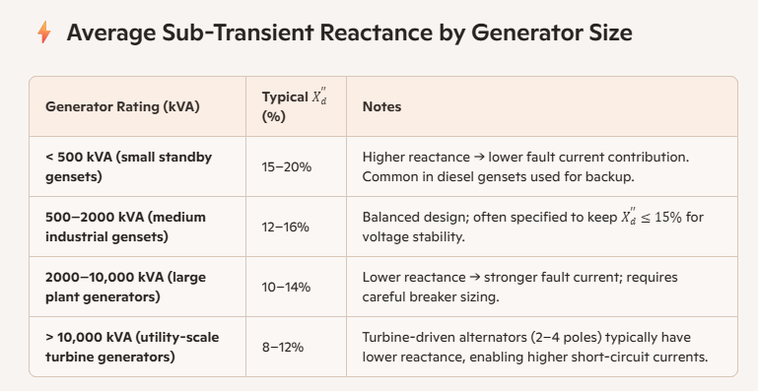

Q10. Fault levels and clearing times
What we have: upstream fault level 350 MVA (CableSizer example) and the Merlin Gerin disconnection-time table.
Why it matters: the upstream fault level sets every fault current; the minimum fault level and the MV protection time decide whether faults are cleared in time.
What we need: the DEWA upstream fault level (maximum and minimum), the MV protection clearing time for the transformer-to-MDB cable, and whether the Merlin Gerin table may be used for all breakers.

This fault level is only for calculating the upstream resistance and reactance values for further calculation of short circuit current downstream; doesn’t need to be related to fault clearing time;

Q11. Interim values – please confirm or correct

Value | We use | Why it matters
Transformer loading limit | 80 % - 100% unless specifically required by user – this can be included as an option checkbox; | when a second transformer is needed
Cable length allowance | 10 % (plus 1 m per cable) – if this is measured value from the layout then add 5m to horizontal length | voltage drop and cable cost
Maximum cables in parallel | 4 runs– no such rules; | when to move to a busbar–upto the user
Load power factor by type | lighting 0.85, sockets / HVAC 0.8, heater 1.0 (CableSizer) – can follow the same with option for editing | current and voltage drop
Target power factor (PFC) | 0.92 (CableSizer) – 0.95 | capacitor bank size
Tray spare allowance | 50 % (CableSizer) – 1D spacing (add all the cable diameter and double them) + 20% spare | tray width
Earthing system (TN-S / TN-C-S?) | not set yet – please tell us– TN-S | earth-fault loop path
Motor starting current | 6.5 × full load (CableSizer) – use the same | motor fault contribution and generator sizing

Q12. Fire-rated cables
What we have: fire & life-safety loads must have fire-rated cable on the generator side.
Why it matters: fire-rated cable is expensive; requiring it on the transformer side too changes cost and design.
What we need: must the transformer side of fire & life-safety loads also be fire-rated?

– Fire rated cables shall be only on the feeders starting from generator along the distribution lines feeding fire life safety loads, even if there is only one feeder down the line feeding fire life safety loads; we could raise a warning or suggestion to the user if only one load is FLS while the entire distribution is fire rated so that the user could change that one feeder directly from the main panel and avoid fire rating the remaining feeders.

Part C – From the Technical Lead / MD

Q13. A reference project to test against
What we have: the Dubai Promenade workbook, but it was saved with broken links to an external file, so many results show #N/A.
Why it matters: acceptance testing (WBS 1.7.5 and 1.8) compares NeuroMEP with a design your team has already checked and issued. Without one we cannot sign the prototype off.
What we need: one hand-checked project with its inputs and issued schedules (a clean copy of Dubai Promenade with its linked DB file would work).

– We can use one of the DCG plots preferably plot-01; Srujan can give this;

Summary – most urgent

Q1 cable tables, Q2 demand factors, Q3 breaker catalogue, Q4 site temperatures and Q13 reference project. Without them NeuroMEP still works, but no result can be issued as Final.
Reply against each question number. Short answers or attached files are fine.

Cable Catalogue - link

